Stonnall Campaign About Roads

# Campaign for a Safer Chester Road

**Detailed report concerning the junctions which border the village of Stonnall and the increasing frequency of incidents & accidents.**

***Section 1 - SCAR***

In 2005 Walsall Council proposed to build the Brownhills Bypass through the fields near Stonnall from Barracks Lane to the Chester Road. The majority of villagers opposed this idea to build in the greenbelt as it could open up further development that would impact the Village. A group of residents formed Stonnall Campaign About Roads (SCAR) and was given the Village mandate to stop Walsall Council building the bypass in that area. SCAR enlisted the help of our Local/District/County Councillors/MP, had a long and well-run campaign and thankfully Walsall Council stopped their plans for the bypass.

In addition to being instrumental in stopping the bypass, SCAR has also been part of the process for various traffic surveys to be commissioned and have consulted on various roads and junctions that were deemed dangerous such as Church Lane. We have been actively involved in trying to reduce the movements of HGV’s through Stonnall Roads, accessing better road signage, and improvements to The Shire Oak junction. In 2021 we successfully implemented improvement works to Cartersfield Lane that now has better signage and a new 40mph limit approaching the village with a view to slowing down speeding traffic.

Some of SCAR’s committee members are also part of the Community Speed Watch initiative.

SCAR is a Company Limited by Guarantee under registration number 5729077 there is a Board of Directors that oversees the running of the company. A Campaign Committee meets several times per year and is responsible for running campaigns and carrying out the actions that the Village has raised. All members are volunteers and SCAR is not politically affiliated or associated in any way. Today, SCAR has over 500 paid up members of the local community that support our activities.

***Section 2 - Chester Road Campaign***

Over recent committee meetings and from attending various community events, such as Stonnallbury, it has become apparent that there is an overwhelming concern from local residents regarding the volume of traffic passing through the village at peak times and the clearly correlated accidents / incidents that are occurring where the village meets the Chester Road.

The primary concern are the junctions of Main Street, Downes Gate, Lazy Hill and Gravelley Lane where they meet or cross the A452 Chester Road (further details of the layouts are provided in Section 4). These junctions present a particular challenge when requesting improvements as they are situated on the border of Staffordshire and Walsall Councils, the people affected the most by these junctions reside within Staffordshire County Council, but the roads and junctions are under the jurisdiction of Walsall County Council.

Its for this reason that SCAR was asked to get involved and lobby for improvements to these junctions before more people are seriously injured or killed in road traffic collisions (RTC’s).

SCAR set up a Campaign Committee consisting of SCAR Directors and local residents, a detailed action plan was developed and delivered over a 3-month period which has culminated in this report and a petition that has gained over **1500** signatures from both residents of Staffordshire, Walsall and surrounding areas who are concerned by the dangerous junctions and the increasing volume of accidents & incidents.

Given the frequency and nature of the incidents occurring at these junctions, this campaign has the support of many local Councillors including: Shenstone Parish Council, Lichfield District Ward Councillors, Local Borough Councillors from Walsall, Councillor Mike Bird of Walsall Borough Council, Councillor David Smith of Staffordshire County Council and Stonnall’s local PCSO Tom Passmore.

The concerns about these junctions have also been sympathetically received by local Members of Parliament and The Police and Crime Commissioner.

***Section 3 – The Local Community***

Stonnall Village has a population of approximately 1500 residents, over 60% of the population are 40 years of age or older, whilst 9% of the population are under the age of 10, having a local primary school, St. Peters, within the village. Over 90% of the residents own their own home meaning people taking pride in their property and they care about the village in which they live, which has resulted in a real positive community feel. The village is served well by local amenities having two pubs, a restaurant, a take-away, and a hairdresser. The village is surrounding by green belt and farmland meaning we have a higher proportion of dog walkers, horse riders and cyclists passing though the village. The village is not served well by public transport which means many residents drive and have to use these junctions several times a day.

A fundamental part of the campaign has been about engaging with the local and wider community to understand their feelings towards these dangerous junctions;

Parents who drop off and collect children from St Peters Primary School voice concerns about the speed of traffic on the Chester Road when having to turn into or out of the village.

Local residents have raised issues around the visibility at the junctions when attempting to cross or turn on to the Chester Road, again compounded by the speed and volume of traffic on the Chester Road.

All the cyclists we consulted with have raised concerns around the speed and proximity at which cars pass them when cycling on the Chester Road and the difficulty they have crossing it due to the approaching speed of vehicles.

Its clear that many people feel vulnerable when approaching and using these junctions, community amenities are an essential life blood of any village which we do not want to be compromised by people avoiding the junctions, thus avoiding the village. Recent accidents and an unfortunate fatality have heightened people’s awareness to the danger when crossing these junctions yet accidents continue to occur at an ever increasing rate emphasising that something more needs to be done.

Over **1500** signatures have been gained on our petition during this campaign, both physical and online, this clearly demonstrates the feeling and voice of the community about wanting something done to improve the safety of these junctions.

The people signing this petition live predominantly in the Stonnall area but many also reside in Walsall Council area and further afield who use this junction.

**Section 4 - The Junctions, Issues, and Impact**

The image below highlights the primary junctions that the campaign is focused on, and whilst most of the incidents and accidents occur at either Lazy Hill or Gravelley Lane, the junctions highlighted should be considered as a collective to prevent traffic issues resolved at one junction being transferred to the next.

*Image: Google Maps*

The village of Stonnall in South Staffordshire sits to the East of the A452 (Chester Rd), which is a historic highway between London and Chester. The road is very busy and popular commuter route between Birmingham, heading north into Staffordshire via Cannock, during peak periods it carries in excess of 1400 vehicles per hour *(Gov traffic data Walsall A452)*. The speed limit on this road rises from 30MPH to 50MPH 500m south of the Shire Oak Junction (A461/A452) running for just under 6KM (3.7 Miles) when it reverts back to 30MPH 160M short of Hardwick Rd (B4151). The road is a two-lane single carriageway road.

Three Junctions labelled A, B, and C, on the map above, have seen numerous traffic related accidents over a number of years including a number of fatalities and serious injuries, however many more minor, none or low injury, accidents occur but are not recorded by the police. There are significantly more “near misses” that could result in an accident or fatality.

The following images provide a more detailed view of the junctions and layouts:

*Fig 1: Google Earth map of all junctions*

*Fig 2. Fig 3.*

Approach A452 from Downes Gate, Giveway sign partially obscured and no indicator to show entering a 50MPH carriageway.

Approach to A452 Chester Rd from Main St. Giveway signage to the left only, partially obscured by tree, speed limit sign in poor condition.

Approach to the A452 Chester Road from Lazy Hill.

No visible signage with the exception of “Giveway” triangle painted on the roadway. Figures 5 and 6 show foliage obscuring all signage, figure 7 shows Giveway sign turned by 90° facing north towards Brownhills.

*Fig 4.*

*Fig 5. Fig 6. Fig 7.*

Approach to the A452 Chester Road from Gravelley Lane.

All signage obscured by overgrown trees and foliage, with the exception of the roadway Giveway triangle – no visible signage.

*Fig 8.*

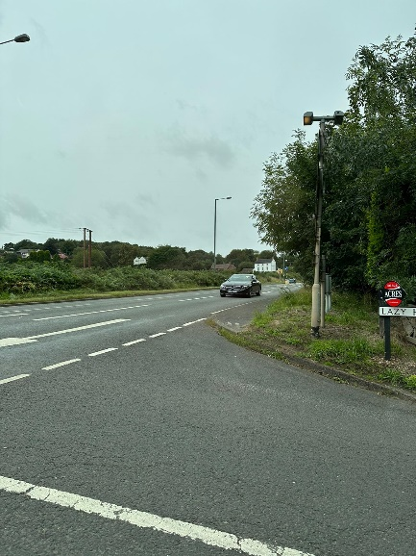

Drivers View:

Approach to the A452 Chester Road from Lazy Hill.

This vehicle is sitting just behind the white Give Way line and the driver is sitting back in the seat as the road in on an incline. The 50m marker is in view, but only just and therefore the driver making the decision whether to go or not has very limited time. This scenario at peak time with higher traffic density on the Chester Road and vehicles on the other side of the crossroads also wanting to pull out results in a much more complex and timely decision process.

*Fig 9.*

It is clear that signage is completely lacking or significantly inadequate from the Staffordshire side of the junctions, all roads approaching Chester Road (with the exception of Gravelley Lane) carry a 30mph speed limit, (Gravelley Lane is national speed limit 60mph).

Traffic travelling at, or in excess of 50mph in either direction of the Chester Road has restricted views of the junctions, traffic travelling from Shire Oak towards Birmingham is a particular concern as there is no indication of the approaching Lazy Hill junction, this is a problem particularly as vehicles gain momentum travelling downhill towards the junction. It is also clear that drivers leaving Stonnall village from Lazy Hill have limited view when pulling out.

Whilst signage at the junctions and visibility / signage approaching the junctions could and should be improved this is not the fundamental root cause of the increased incidents and accidents. As always, speed is a contributing factor, and this section of the Chester Road is 50mph and not regulated by cameras, but again is not the root cause of the increased incidents and accidents.

The primary issue is the increased volume of traffic using the village as a means of avoiding the Shire Oak junction at peak times. This increased volume coupled with a lack of patience and understanding of priority at the crossings is the cause of the majority of the incidents / accidents.

This image has been taken from Main Street, approximately 75m from the junction of Lazy Hill and Chester Road, the queue extends for another 100m into the village, taken at 8am. This results in drivers becoming frustrated and making poor decisions at the junction or just a lack of understanding at the junction of who has priority.

*Fig 10.*

A recent survey carried out by Staffordshire County Council **(Project Name: Lichfield Rural South, Document Title: Traffic Study – Lichfield South)** has shown that the traffic volume using Cartersfield Lane has significantly increased, almost doubled, many residents that have lived in the village for a long time have cited a significant increase in the volumes of traffic at the junctions of Lazy Hill and Gravelley Lane at peak times.

As with any junction, and in particular crossroads, when traffic volumes are high people become impatient to wait their turn and monitoring traffic approaching from the left and right, at 50mph or greater, together with trying to gauge what the driver on the opposite side of the junction is going to do inevitably leads to mistakes and results in accidents.

Freedom of information requests were submitted to both Staffordshire Police and West Midlands Police requesting all information relating to accidents at both the junctions of Lazy Hill & Chester Road and Gravelley Lane / Birch Lane & Chester Road. The response from Staffordshire Police stated that they don’t not hold data on these junctions. The response from West Midlands Police was as follows:

*RESPONSE*

***Data pre-2022*** *- Under section 21 of the Freedom of Information Act, we are not required to provide information in response to a request if it is already reasonably accessible to you.*

*The information you require is freely available to the public via several websites. Two such examples, which also provide useful interactive maps, can be found at the following links:* [*https://www.think.gov.uk/thinkmap/*](https://eur03.safelinks.protection.outlook.com/?url=https%3A%2F%2Fwww.think.gov.uk%2Fthinkmap%2F&data=05%7C01%7Cadrian.floyd%40the-mtc.org%7C807150a25fa2433f89e008dbc635b9a7%7C78d71610c4a14bef9f100192e83ee6d8%7C0%7C0%7C638321706315296000%7CUnknown%7CTWFpbGZsb3d8eyJWIjoiMC4wLjAwMDAiLCJQIjoiV2luMzIiLCJBTiI6Ik1haWwiLCJXVCI6Mn0%3D%7C3000%7C%7C%7C&sdata=tIm9NN%2BZ%2Bjgb4u5RSmai%2B3y32SnH3bK0kDErUXyK3cM%3D&reserved=0)[*https://www.crashmap.co.uk/Search*](https://eur03.safelinks.protection.outlook.com/?url=https%3A%2F%2Fwww.crashmap.co.uk%2FSearch&data=05%7C01%7Cadrian.floyd%40the-mtc.org%7C807150a25fa2433f89e008dbc635b9a7%7C78d71610c4a14bef9f100192e83ee6d8%7C0%7C0%7C638321706315296000%7CUnknown%7CTWFpbGZsb3d8eyJWIjoiMC4wLjAwMDAiLCJQIjoiV2luMzIiLCJBTiI6Ik1haWwiLCJXVCI6Mn0%3D%7C3000%7C%7C%7C&sdata=TvjNqbiQ79Lb2CJieq3OSUuBqZKxoNf5lYu0ohHuXOw%3D&reserved=0)

*Further details of Section 21 can be found here:* [*https://www.college.police.uk/app/information-management/freedom-information#foia-section-21-information-reasonably-accessible-by-other-means*](https://eur03.safelinks.protection.outlook.com/?url=https%3A%2F%2Fwww.college.police.uk%2Fapp%2Finformation-management%2Ffreedom-information%23foia-section-21-information-reasonably-accessible-by-other-means&data=05%7C01%7Cadrian.floyd%40the-mtc.org%7C807150a25fa2433f89e008dbc635b9a7%7C78d71610c4a14bef9f100192e83ee6d8%7C0%7C0%7C638321706315296000%7CUnknown%7CTWFpbGZsb3d8eyJWIjoiMC4wLjAwMDAiLCJQIjoiV2luMzIiLCJBTiI6Ik1haWwiLCJXVCI6Mn0%3D%7C3000%7C%7C%7C&sdata=VMUGxy%2FIRM351ZX2F7XtChUA%2B0dHdL%2BARHkpQhtLuXo%3D&reserved=0)

***Data from 2022*** *- Under section 22 of the Act, we are not required to provide information in response to a request if it is already scheduled to be released into the public domain. While release of this information may enhance public knowledge, to respond to this request at this time would require the information to be retrieved and collated and would involve a disproportionate use of resources. In addition, uncoordinated release of this information, before the data are properly verified could result in the release of misleading data.*

*Websites such as the examples above source their information from data that is collected, checked and published by the Department for Transport (DfT)* [*Road Safety Data - data.gov.uk*](https://eur03.safelinks.protection.outlook.com/?url=https%3A%2F%2Fwww.data.gov.uk%2Fdataset%2Fcb7ae6f0-4be6-4935-9277-47e5ce24a11f%2Froad-safety-data&data=05%7C01%7Cadrian.floyd%40the-mtc.org%7C807150a25fa2433f89e008dbc635b9a7%7C78d71610c4a14bef9f100192e83ee6d8%7C0%7C0%7C638321706315296000%7CUnknown%7CTWFpbGZsb3d8eyJWIjoiMC4wLjAwMDAiLCJQIjoiV2luMzIiLCJBTiI6Ik1haWwiLCJXVCI6Mn0%3D%7C3000%7C%7C%7C&sdata=lpp4UqB9%2Fho2khrTVuWkXizVt71V73L7S8GV0NvjNkE%3D&reserved=0) *and the information you require for 2022 onwards will be published on the DfT website, and then in due course, in an easier to read interactive map format on the aforementioned websites above and similar.*

SCAR has therefore used the data from Crash Map ([www.crashmap.co.uk](http://www.crashmap.co.uk)) to provide an overview of the reportable incidents from the period 2012 to 2021, with more than 1 vehicle involved in an incident at or approaching the junctions.

|  |  |  |  |  |
| --- | --- | --- | --- | --- |
| Junction with A452 | Slight | Serious | Fatal | Total |
| Main Street | - | - | - | 0 |
| Downes Gate / Castlehill | 1 | - | - | 1 |
| Lazy Hill | 7 | 2 | 1 | 10 |
| Gravelley Ln / Birch Ln | 5 | 1 | - | 6 |
| Aldridge Rd / Little Aston Rd  (Double Island @ Irish Harp) | 1 | - | - | 1 |
| Comparison to Streetly where traffic lights exist at every crossroads | | | | |
| Hardwick Rd Traffic Lights | 2 | - | - | 2 |
| Foley Rd Traffic Lights | 4 | - | - | 4 |
| Bridle Ln / Manor Rd Traffic Lights | 2 | - | - | 2 |

The above statistics are reportable incidents only recorded by the police; however, the data speaks volumes regarding the disproportionally high number of incidents at both the Lazy Hill and Gravelley Lane junctions, and when compared to Aldridge Rd or any of the junctions in Streetly where traffic flow and speed is regulated by islands or traffic lights both volume and severity of incidents is significantly reduced.

Furthermore, since starting this campaign and given little data is available post 2021 from official websites the SCAR Committee Group with the support of the community has been recording all incidents at either Lazy Hill or Gravelley Lane, regardless of whether its police reportable or not.

Since the start of 2023 Lazy Hill junction has seen **10 incidents**, including the unfortunate fatality of a cyclist in February. There have also been a further **6 incidents** at the Gravelley Lane junction (Witness statements are attached in Appendix A).

The number and frequency of these incidents cannot continue to be ignored as we fear it will lead to more serious injuries and fatalities.

Within industry any near miss results in a full internal investigation and corrective actions being implemented to prevent future occurrence. If a serious injury or fatality occurs in industry the HSE carry out full investigations and sites can be severely fined, imprisoned or shut down. It appears the same rigor and approach to the safety of pedestrians, cyclists and drivers is not considered necessary and something needs to be done to change this.

**SCAR will not accept that these junctions are safe or that nothing can be done to improve the safety for all that use them.**

The layout of these junctions and the impact they have on the local community goes beyond the safe crossing of them. The Gorse Farm development cited access to Stonnall for local amenities and access to public transport, the village welcomes new residents, and we want our local amenities to thrive and prosper. However, the Highways Development Control stated the current lack of footpaths and no formal pedestrian crossing point across the Chester Road, which is a strategic road with a 50mph speed limit, to allow pedestrians to safely cross and access the village, amenities, and local bus stops. The Highway Authority considers that the development will potentially have an unacceptable impact on road safety and is contrary to the NPPF 2021 paragraph 110,111 and 112.

Conversely, much larger developments proposed by Walsall Council, such as Home Farm, could have a significant negative impact on these junctions if traffic volumes and speed are not controlled with more appropriate measures. The increased volumes and speed of traffic, both travelling through the village and on the Chester Road, itself would inevitably result in more accidents and potentially fatalities if these junctions are not improved.

**Section 5 - Recommendations and Next Steps**

SCAR kindly requests a follow up meeting with the Councils and Highways Agency to discuss and consider the following points:

1. Improved signage at and on the approach to the junctions
2. Traffic volume and speed surveys to be carried out at both Lazy Hill and Gravelley Lane junctions on all approaches (i.e. Chester Rd north & south, Lazy Hill, Gravelley Lane, Birch Lane).
3. Video capture equipment to record all incidents at the junctions not just police reportable.
4. Consider all options available to reduce incidents such as traffic lights / islands/ no-right turns, no entry, etc. All options should be presented before being discounted.
5. Finally, support from Councils and Highways Agency to work together to prevent further serious injuries and fatalities, doing nothing is not an option.

**Appendix A – Witness Statements and Diagrams**

**1**

At around 4.00pm on Friday 16th June I drove down Lazy Hill, stopped at the Chester Road junction, and waited to cross over to Main Street. There was a lot of traffic, continuous both ways, on the Chester Road, a queue had formed behind me and there was a queue waiting to come out of Main Street. There was one vehicle waiting stationary in the middle of the Chester Road indicating right to turn into Lazy Hill and two vehicles indicating right waiting to turn onto Main Street, Vehicles B and C on the diagram. Basically, the junction could not have been busier. No-one waiting on Main Street or Lazy Hill or the vehicles waiting to turn off the Chester Road could move because the Chester Road traffic was continuous both ways for some minutes. After a while, the male driver in Vehicle A tooted his horn at Vehicle B, presumably hoping to encourage the driver to nip through a short gap in the traffic and clear his way so that he could do the same and cross over onto Lazy Hill. Both manoeuvres would have been dangerous in the volume of traffic at the time. Vehicle B didn’t move so the driver of Vehicle A tooted the horn twice, then several times, then held his hand on the horn so that it was blaring permanently. Vehicle B then did nip across the carriageway onto Main Street through a small gap in the traffic (I wouldn’t have done it – it wasn’t safe) and Vehicle C followed. However, the driver of Vehicle B stopped parallel to Vehicle A (who still couldn’t move out of Main Street because Vehicle C was blocking the way) and the two drivers exchanged angry words. Because Vehicle B had stopped and Vehicle C had attempted to follow, Vehicle C was left blocking the carriageway of the Chester Road. A couple of cars went round Vehicle C, crossing over onto the opposite carriageway which was still busy to do so. The angry exchange only lasted for a short time, less than a minute, and Vehicles B and C drove off down Main Street. Vehicle A still couldn’t move because of the continuous traffic on Chester Road so it had all been for nothing yet could have caused a serious incident. I gave up trying to cross over the Chester Road, turned left and went into Stonnall via the little road that leads past Marlais House. I have never encountered traffic on that small part of the road before but there were three other cars turning onto it at the same time as me yesterday.

Living on Cartersfield Lane, I know how much traffic uses Stonnall as a rat run during the rush hours at either end of the day in order to avoid the traffic lights at Shire Oak and I can pretty much guarantee that the queue at the top of Main Street headed by Vehicle A was in part, if not entirely, made up of these people who then get angry because they have tried to save time and have failed. Something desperately needs to be done before there is another fatality as the Main Street/Chester Road junction is essentially a route in and out of a village and is just not suitable for large volumes of traffic at peak times.

**2** 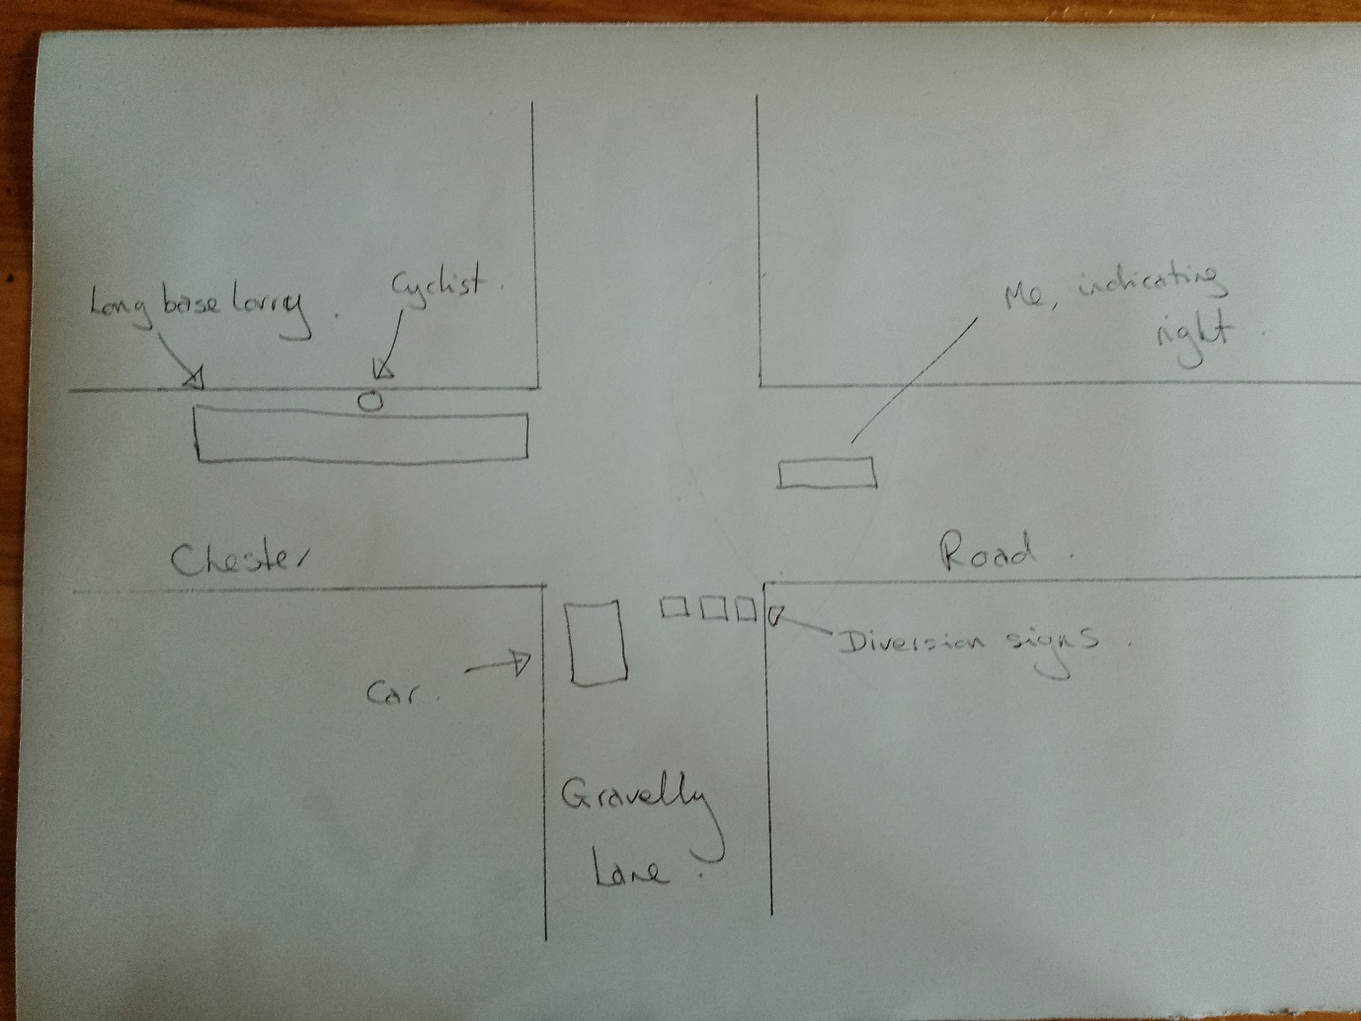

I was waiting, indicating to turn right onto Birch Lane/Stonnall Road. There was an extremely long based covered lorry waiting to turn right onto Gravelly Lane and a car in Gravelly Lane waiting to cross the Chester Road onto Birch Lane/Stonnall Road. A cyclist was coming alongside the lorry. The cyclist and the parked car were invisible to each other because the lorry was in the way. Half of the entrance to Gravelly Lane was blocked off with several diversion signs – even if they had not been there, the lorry was too big to turn into Gravelly Lane whilst the car was waiting to pull out, so the lorry driver flashed the car driver to go first. The cyclist appeared from behind the lorry just as the car pulled out of Gravelly Lane to cross the Chester Road and the car missed him by maybe a metre or so at most. It all happened so quickly that I was unable to wave to the car driver to stop. I screamed as I thought that the cyclist was hit, it was so close.

**3**

For SCAR file, another incident at Lazy Hill junction at c3.30pm 27th July 2023.

This incident involved me and Mrs W.

We were heading along The Chester Road from Birmingham direction and waiting to turn right into Lazy Hill towards Stonnall Village.

It was busy with traffic in all directions.

The Red Bus from Stonnall to Aldridge was waiting to cross the Chester Road at Lazy Hill on the Stonnall side facing Lazy Hill Aldridge.

We could not turn right into Lazy Hill off the Chester Road because the bus straddled the road and there wasn’t enough room for us to manoeuvre passed the bus into the Village, so we waited for the bus to move across The Chester Road.

There was no gap in the traffic movements both directions on The Chester Road.

After several minutes a slowdown of traffic happened coming from the Brownhills direction and so the bus pulled out and stopped in the middle of the road waiting for vehicles coming from the Birmingham direction to stop.

Many vehicles passed through from Birmingham direction and so the bus waited in the middle of the road for a few minutes.

By this time, cars started to speed around the corner from Brownhills and had to halt because the bus was in their way.

The bus was nudging inch by inch further across The Chester Road resulting in several near misses until a car stopped and let the bus through.

In both directions cars had to break severely to avoid this hazard and dangerous situation.

There were passengers on the bus and this could have resulted in a major incident but thankfully and luckily somehow, it didn’t.

More proof that something needs to be done about this junction.

**4**

I was stopped at the bottom of Lazy Hill road crossing the Chester Road in the direction of Stonnall. From my left was a BMW heading down the hill from Shire Oak to turn right to go up Lazy Hill Road towards Aldridge. There was a car opposite me waiting to turn right onto the Chester Road going towards Shire Oak. The BMW flashed me and was looking at me to give way to me to go straight on. The car opposite saw this as his invitation to cross ahead of me almost hitting me & the BMW. Luckily, I was slower at pulling out and had time to stop.

**5**

Travelling along the Chester Road towards Shire Oak I indicated right into Gravelly Lane. The car sat waiting in Gravely Lane rushed out ahead of me to go straight on up Birch Lane. The car was near me & oncoming traffic from Shire Oak. A few meters and he would have hit the car coming towards me and they would have both hit my car.

6

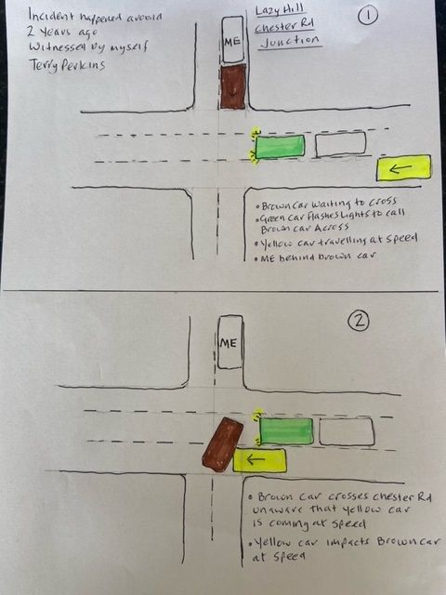

Sorry it’s taken a while to get back to you, I have had a busy couple of days.

As requested please see above a sketch and notes of the incident I witnessed.

**7** As usual I take my two Labs for a walk early doors.

This morning by car and we decided to go to Sutton Park.

On returning and driving up Chester Rd towards Shire Oak, I signalled in preparation to turn right into Lazy Hill. Made the move to the central reservation and then planned to wait in the central area to wait for an appropriate time and space to turn right into Lazy Hill.

I held back as other cars; vans were before me and also trying to cross the junction as per the Highway code.

Shocked to observe that from the left, a flat back pick up crossed ,be it very slowly but safely to be then followed by a grey van  and now very dangerously, why ?.

There was no time with an oncoming van driving South towards me and having to swerve at speed to avoid the van and then me.

The look on the face of the driver in a small white van with a hi viz jacket as he avoided me was unbelievable!

Hopefully all caught on my dash cam.

To be advised later.

I ended up following these two vehicles down Main St and hopefully have their registration, but I honestly believe that they have no idea what carnage they could have caused.

Finally for the SCAR group that I fully support.

I note that there are CCTV cameras at a lay by before the car dealership on Chester Rd to prevent fly tipping which I totally support.

Why cannot S.C.C. and Walsall Council consider the same at Gravelly Lane and Lazy Hill Junctions and observe what we see every day at rush hour time.

Just a thought as we have already had fatalities at these junctions, but do we need more to make an impact?